1. what is the output ?
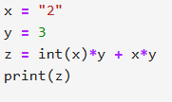
A) 6
B) 26
C) 68
D) Error
Answer: D
2. what is the output ?
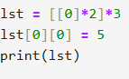
A) [[5,0],[0,0],[0,0]]
B) [[5,0],[5,0],[5,0]]
C) [[0,5],[0,0],[0,0]]
D) Error
Answer: B
3. what is the output?
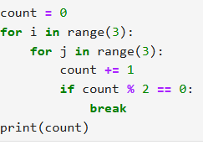
A) 2
B) 3
C) 4
D) 5
Answer: C

4. what is the output?
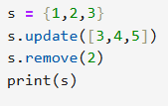
A) {1,2,3,4,5}
B) {1,3,4,5}
C) {1,3,5}
D) {2,3,4,5}
Answer: B
5. what is the output?
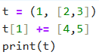
A) (1,[2,3,4,5])
B) (1,[2,3])
C)Type Error
D) (1,[4,5])
Answer: C
6. what is the output?
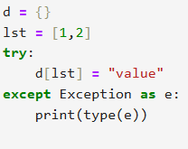
A) <class 'TypeError'>
B) <class 'KeyError'>
C) <class 'ValueError'>
D) None
Answer: A
7. what is the output?
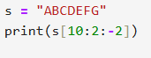
A) GE
B) GFED
C) GEC
D) ""
Answer: A
8. what is the output?
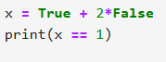
A) True
B) False
C) Error
D) None
Answer: A
9. what is the output?
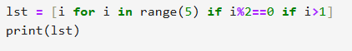
A) [0,2,4]
B) [2,4]
C) [1,3]
D) [0,1,2]
Answer: B
10. what is the output?
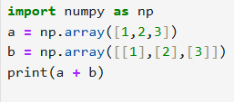
A) [[2,3,4],[3,4,5],[4,5,6]]
B) [[2],[4],[6]]
C) [2,4,6]
D) Error
Answer: A

11. what is the output?
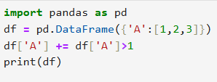
A) 1 2 3
B) 1 3 4
C) 2 3 4
D) Error
Answer: B
12. what is the output?
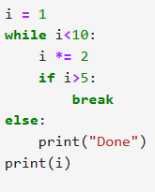
A) Done 8
B) 8
C) Done 6
D) 6
Answer: B
13. what is the output?
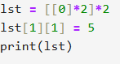
A) [[0,0],[0,5]]
B) [[0,0],[5,0]]
C) [[0,5],[0,5]]
D) [[5,0],[5,0]]
Answer: C

14. what is the output?
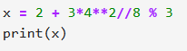
A) 2
B) 3
C) 4
D) 5
Answer: A
15. what is the output?
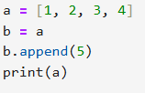
A) [1, 2, 3, 4]
B) [1, 2, 3, 4, 5]
C) [5, 1, 2, 3, 4]
D) Error
Answer: B
16. what is the output?
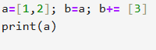
A) [1,2]
B) [1,2,3]
C) [3]
D) Error
Answer: B
17. what is the output?
A) {1,4}
B) {2,3}
C) {1,2,3,4}
D) {1,2,4}
Answer: A
18. what is the output?
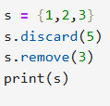
A) {1,2,3}
B) {1,2}
C) {2,3}
D) Error
Answer: B
19. what is the output?
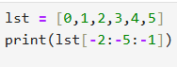
A) [4,3,2]
B) [3,2,1]
C) [4,3,2,1]
D) Error
Answer: A
20. what is the output?
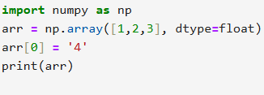
A) [4.0,2.0,3.0]
B) ['4',2,3]
C) Error
D) [1,2,3]
Answer: A
21. Which of the following will raise an error?
A) int('123')
B) float('12.3')
C) int('12.3')
D) str(123)
Answer: C

22. What is the value of:
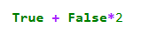
A) 1
B) 2
C) 0
D) Error
Answer: A
23. Which of the following is mutable?
A) tuple
B) list
C) string
D) frozenset
Answer: B
24. What is the output?
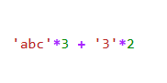
A) 'abcabcabc33'
B) 'abc3abc3abc3'
C) 'abcabcabc6'
D) Error
Answer: A
25. What happens if you try to use a list as a key in a Python dictionary?
A) Python automatically converts it to a tuple
B) It works fine as long as the list has numbers
C) Python raises a TypeError
D) The dictionary stores the reference but not the value
Answer: C
26. Which of the following statements about Python loops is true?
A) A for loop can only iterate over numbers
B) else in loops executes only if loop completes normally without break
C) while loops execute at least once
D) break ends only the outermost loop
Answer: B
27. What does // operator do in Python?
A) True division
B) Floor division
C) Modulus
D) Exponentiation
Answer: B
28. Which of the following is hashable and can be used as a dictionary key?
A) List [1,2]
B) Tuple (1,2)
C) Dictionary {1:2}
D) Set {1,2}
Answer: B
29. Which of the following is not a valid set operation in Python?
A) s1 & s2
B) s1 | s2
C) s1 % s2
D) s1 ^ s2
Answer: C
30. Which statement about Python strings is true?
A) Strings are mutable
B) Strings can contain lists
C) Strings support slicing
D) Strings support in-place addition
Answer: C
31. Which of the following Pandas functions returns a Series of boolean values based on a condition?
A) df.select_dtypes()
B) df.isnull()
C) df['A']>1
D) df.describe()
Answer: C
32. Which of the following Pandas functions returns a DataFrame based on a condition?
A) df.select_dtypes()
B) df.isnull()
C) df[df['A']>1]
D) df.describe()
Answer: C
33. Which statement about Python dictionaries is true?
A) Keys must be mutable
B) Dictionaries maintain insertion order
C) Values must be unique
D) Dictionaries cannot contain lists as values
Answer: B
34. Which of the following statements about Python sets is true?
A) Sets are ordered
B) Sets allow duplicate elements
C) Sets are mutable
D) Sets can be indexed
Answer: C
35. Which of the following will not throw an error?
A) x = '5' + 5
B) x = int('5') + 5
C) x = float('5.2') + '5'
D) x = [1,2] + (3,4)
Answer: B
36. Which of the following is valid slicing?
A) s[::2]
B) s[2::]
C) s[::-1]
D) All of the above
Answer: D
37. Which of the following methods will remove an element from a set without raising an error if the element does not exist?
A) set.remove()
B) set.discard()
C) set.pop()
D) del set[element]
Answer: B
38. Which of the following NumPy array properties gives the number of dimensions?
A) arr.shape
B) arr.size
C) arr.ndim
D) arr.len
Answer: C
39. Which of the following statements about Python operators is true?
A) / performs floor division
B) // performs true division
C) % gives remainder
D) ** gives remainder
Answer: C
40. which of the following is a fundamental datatype?
A) string
B) List
C) set
D) dict
Answer:A

